- The Website is much better than before but needs some development in detailed manner with more illustrated pictures, references and links to other sites.
- This website target teachers and parents so the pictures should be more appropriate for this type.
- the correction is listed after the picture for main changes have put some snap shots.

Remove this picture please and replaced it with this:
https://www.google.com/url?sa=i&rct=j&q=&esrc=s&source=images&cd=&cad=rja&uact=8&ved=2ahUKEwiZjqK2oO3eAhWNyoUKHYe-ATcQjRx6BAgBEAU&url=https%3A%2F%2Fwww.ligaturejournal.com%2Fi-have-dyslexia%2F&psig=AOvVaw3N_brc5erWPQtDTK5bhMkQ&ust=1543156542450307
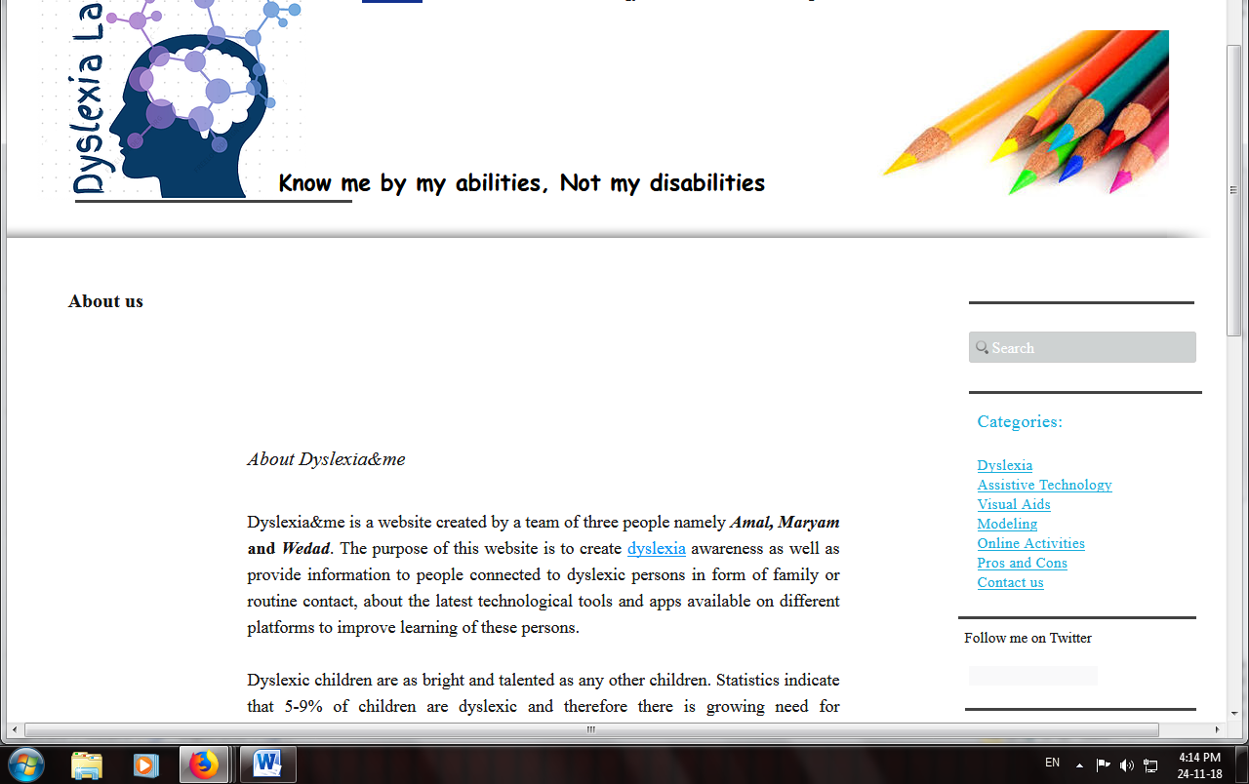
Follow Us and Twitter should be live not linked
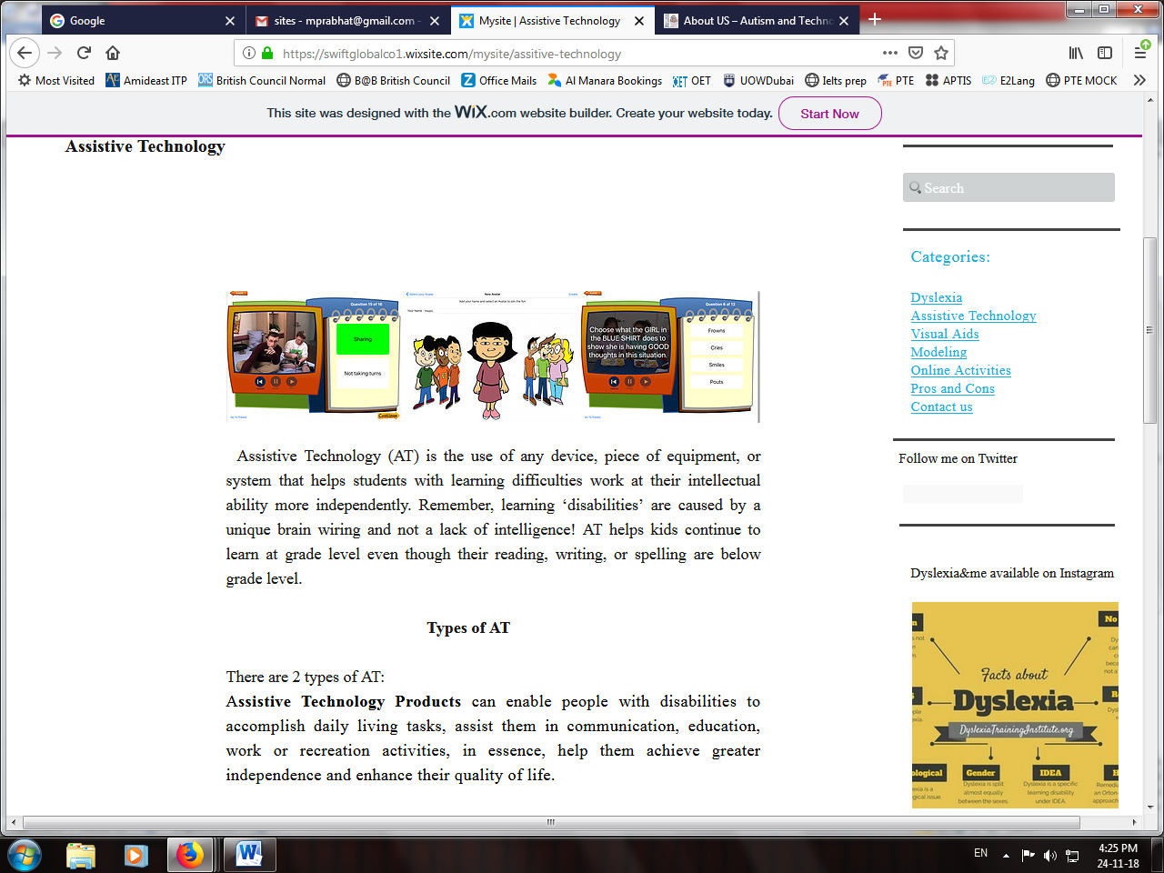
Both the types of AT should be in different color or style to be identified easily.
It’s a long gap need to be smaller on all sections and the title should be with a bigger font.

- All the video and figures should have captions and references in all sections.
- Visualization section in visual Aids. Needs references and some video/ pictures as sample.
- Example of Visualization section in visual Aids. Needs to be developed with more description and with some visuals.
- Importance of Visualization section in visual Aids. Needs some pictures and videos links to other sites.
- MODELING is lots of text lacks pictures and Videos in reflection you have discussed about videos ( Where is the Videos to support the reflection)
- Need Reflection in all the sections its missing in (Online Activity)
- Need to improvise on cons and pros with some pictures illustrating it. Link to other sites to help understanding.
- Reflection section in every part should answer the following question from the rubric.
  - Why did you select this artifact or element?
  - How did you benefit from this activity?
  - How did this artifact help you to achieve the course objective?
  - How did the artifact influence the meaningful learning and thinking?

